THIS IS THE QUESTION 1 OUTPUT

FIRST I COMPILE SERVER.JAVA AND CLIENT.JAVA

After that start rmiregistry And run server

And after that run client

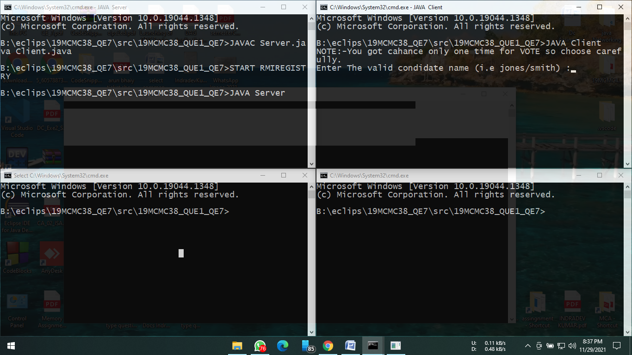

I put Aditya as a condidart name and then prompt say

This is wrong input :-This is not valid condidate please choose smith or jones

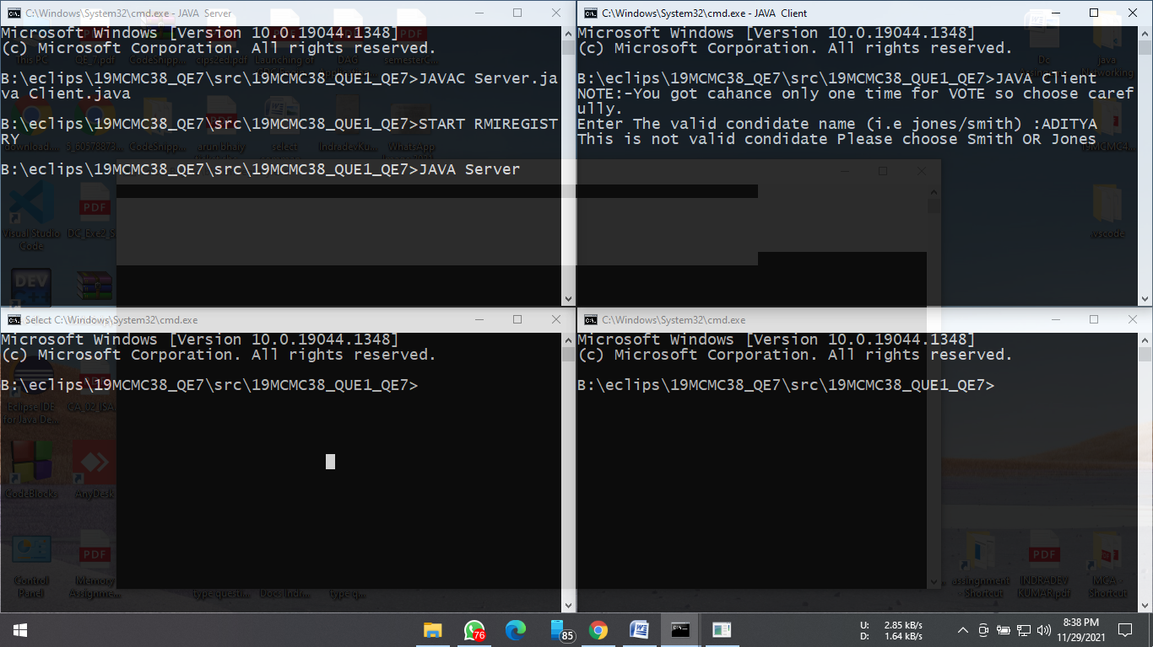

Start client in third terminal and enter the condidat name is smith

Then client is waitting for result (if client enter end then it’s show the reult).

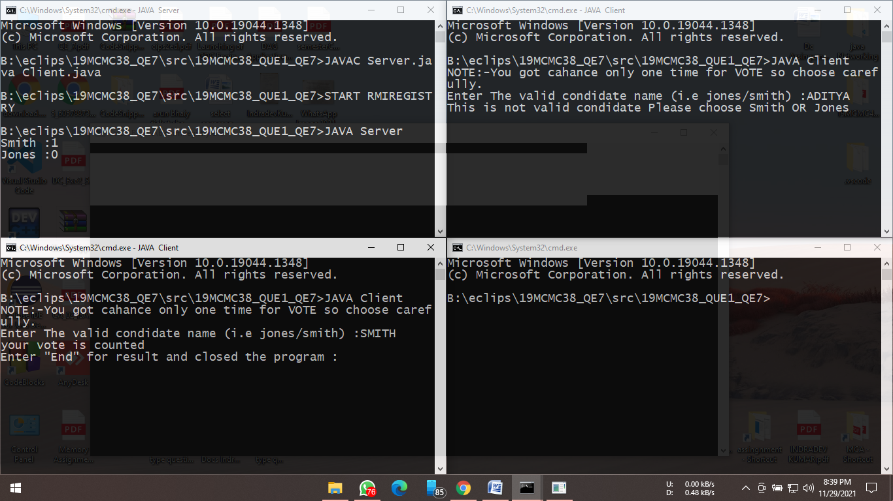

In second terminal choose jones

This is also waitting for reslut....

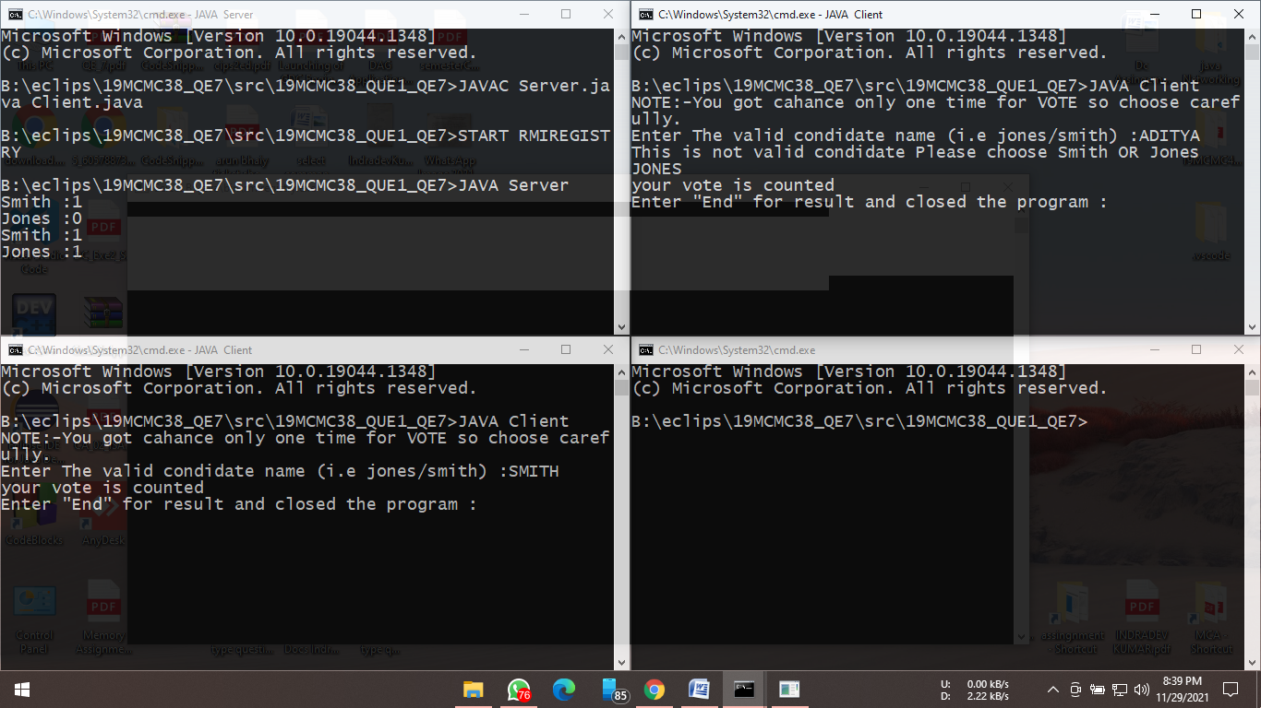

Run the 4th client and give the vote smith wait for result....

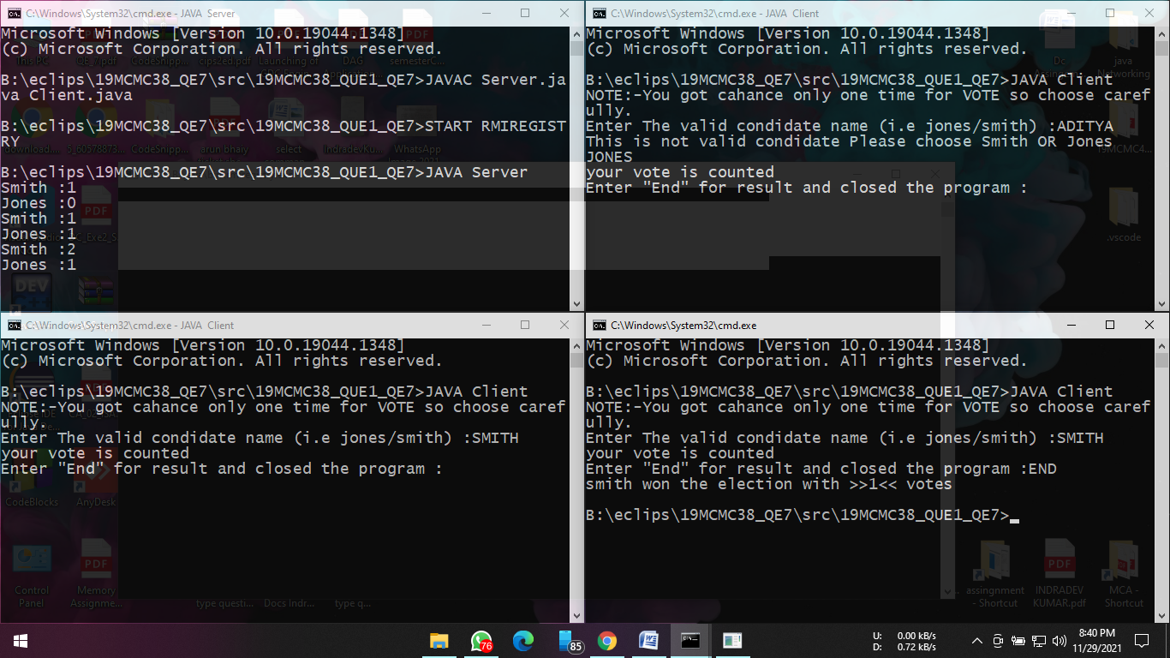

Int 4th terminal for showing the result put end then seen the result..

And in 2nd terminal i put wrong input for shwo result (i.e worng input )

